HPVsim personal bug report
  - Results as they were before
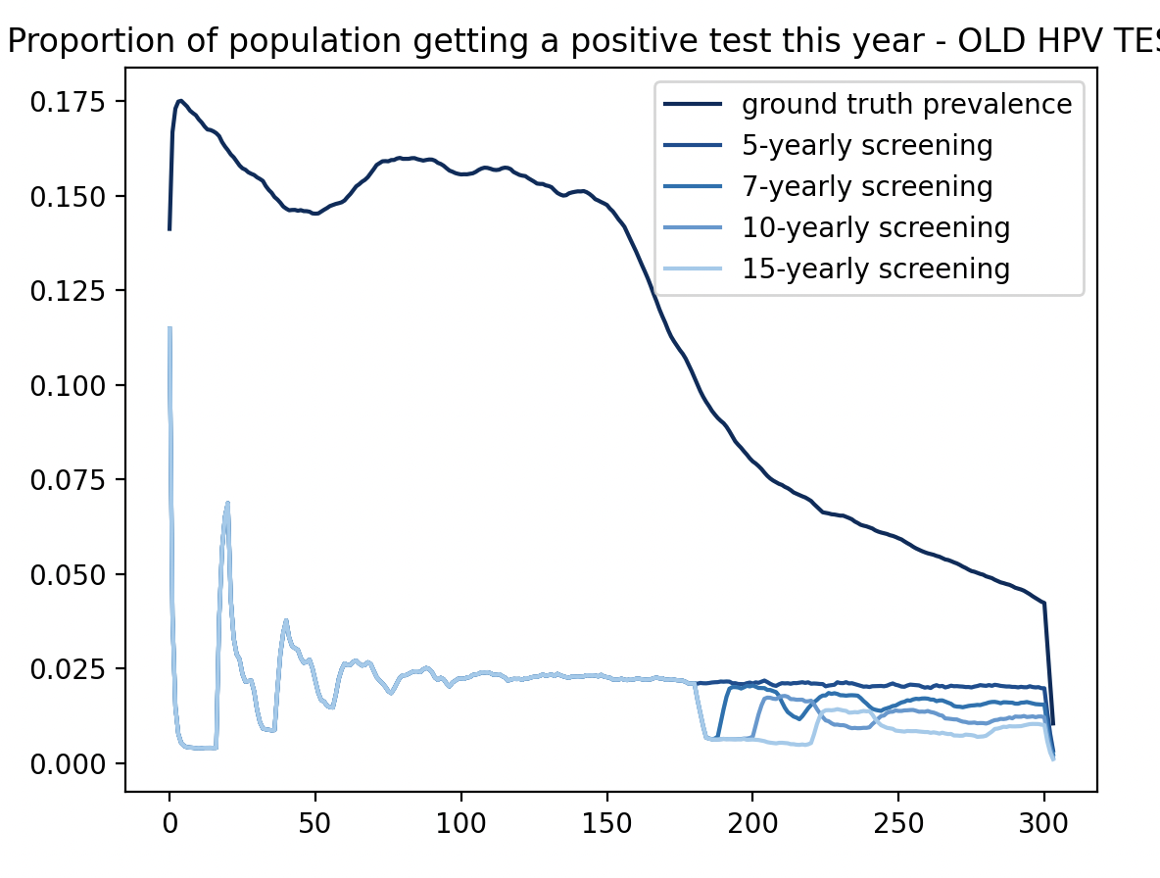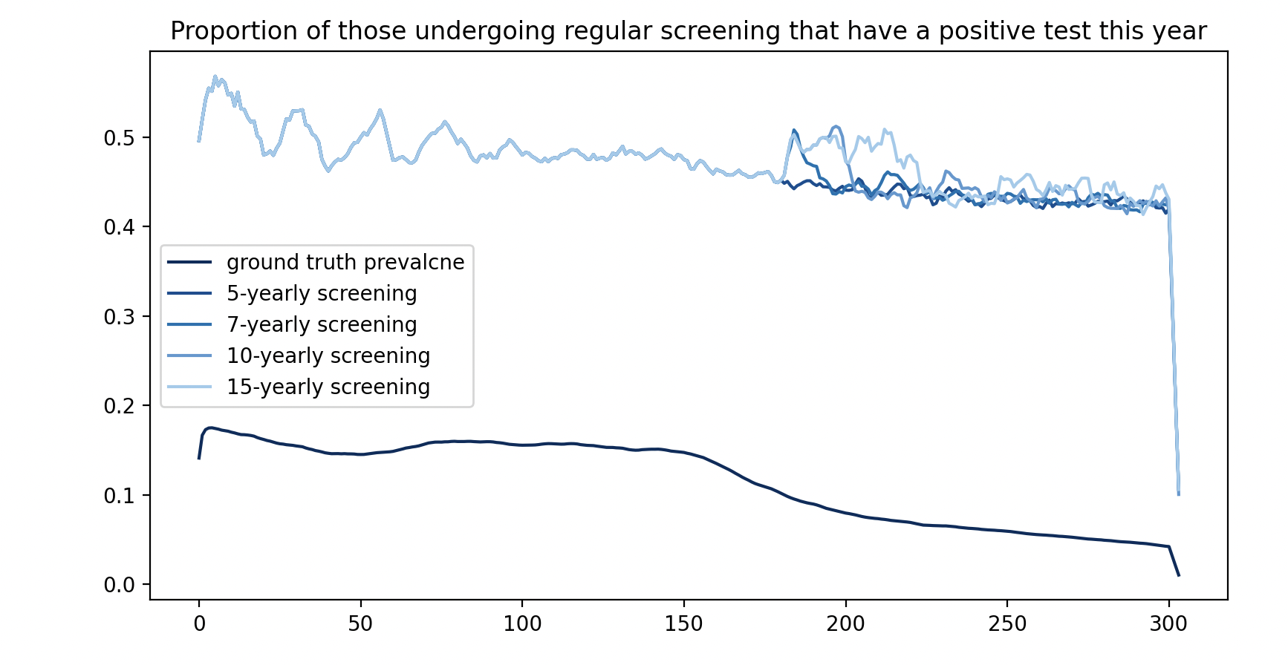
And the dx file as it was before:the
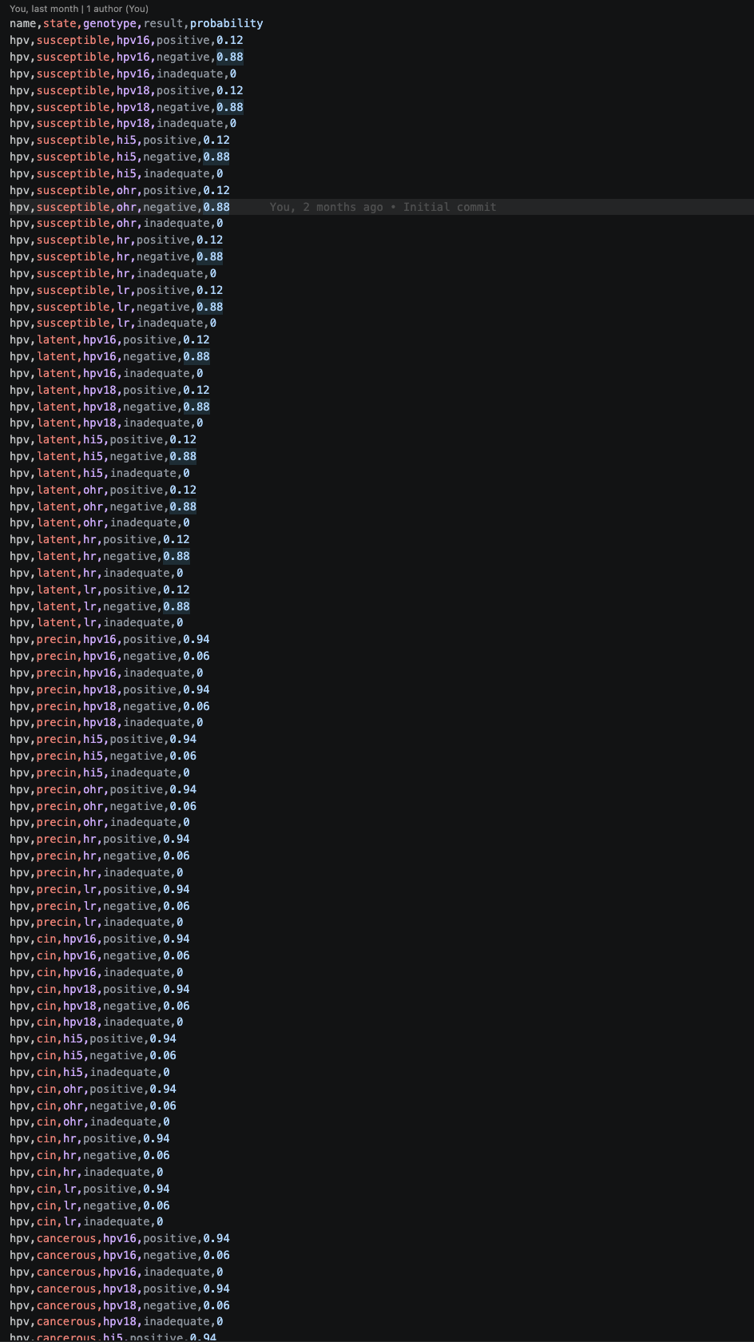
  - My changes to the dx file – replacing genotype-wise spercification (like in the HPVsim example) with ‘all’ specification
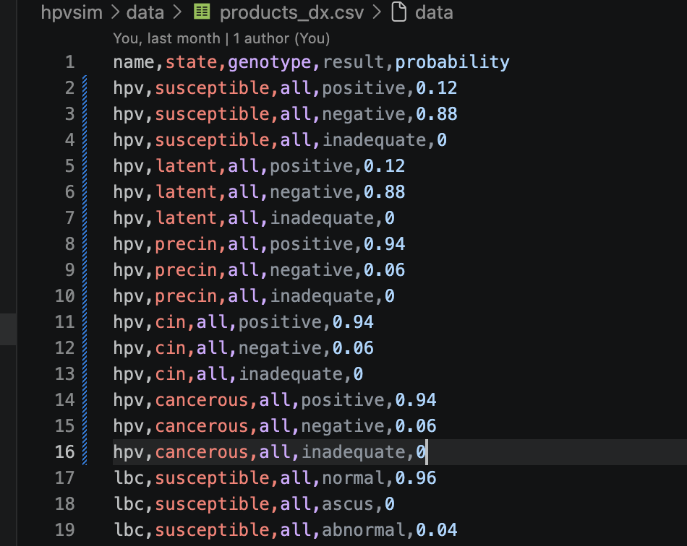
  - The results now
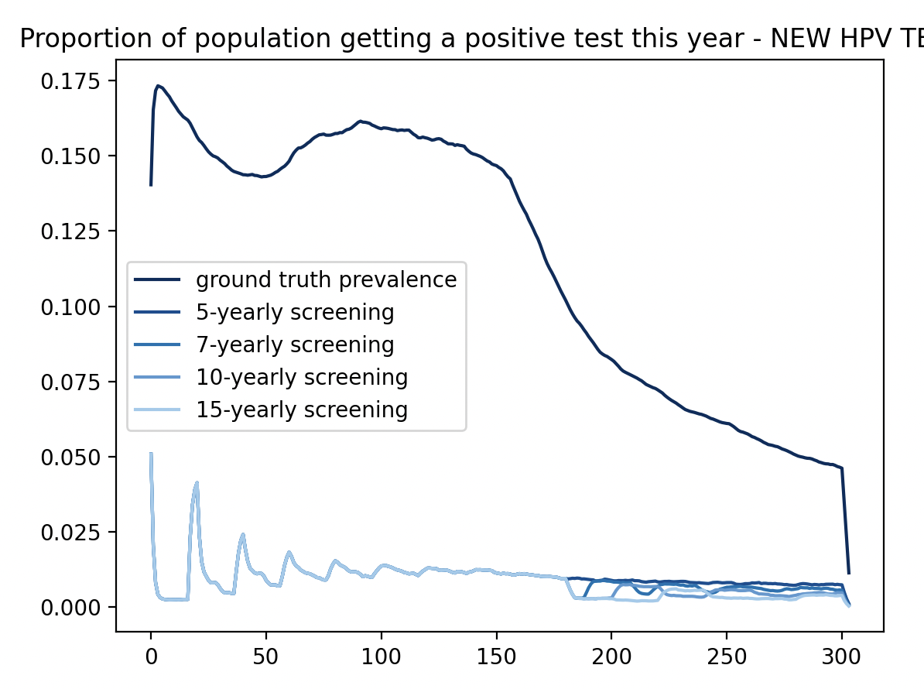
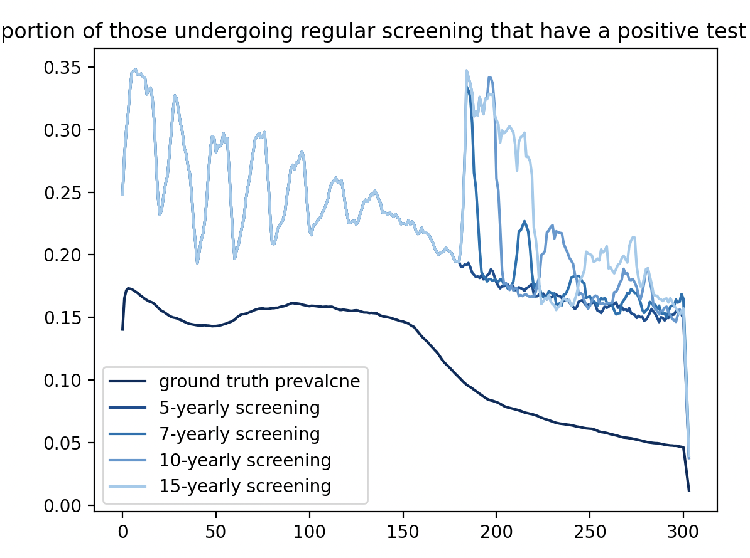

  - A justification about what happened
I have 4 logical genotypes (hpv16, hpv18, hi5, ohr). Agents in the susceptible state necessarily are susceptible for all 4. This means each genotype, when tested separately, has a 0.12 probability of yielding a positive test (which if I understand correctly, has higher priority than negative/inadequate tests, so any positive means the full test is considered positive). This means each susceptible person has an overall 0.4 probability of havinga positive test. Ultimately, this modelled specificity is much too low as a result of misunderstood/unclear definition of how to define these tests, and many too many people are getting psotiive tests. This would explain why things are so squished up so high,andn not getting much change in test outcomes as a function of ground truth prevalence.

With this better model, we now have much better specificity, so the very high number of susceptible people (by far most people going through screening) now doesn’t lead to a massively high number of positive tests. We still have a bias towards a higher observed fraction of pspitive tests than should be, but that is expected.
I am not sure how this impacts the rest of my modelling though – it does explain the large number of positive tests in the Sankey diagram (which I had inacurrately attributed to higher weighting for agents with cancer), but I should at least re-check against my calibrated parameters to see if they still work.

  - Evaluating existing main sensitivyt analysis calibration with the changed specificity of tests – does it change much? Hoping maybe it doesn’t because of how we are running through lbc and colposcopy before actual treatment happens which should thin things out to remove hopefully enough false positives to get decent results.
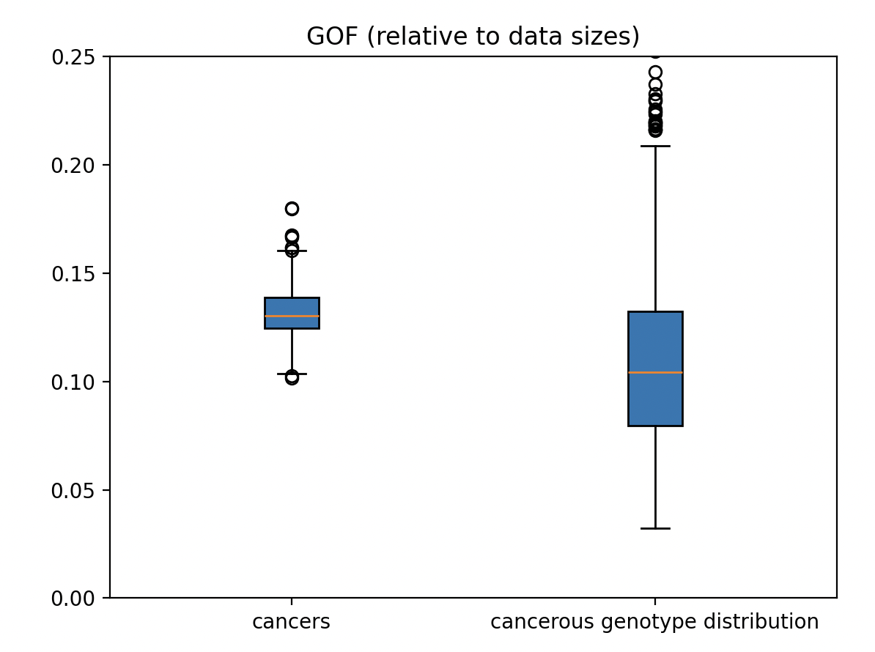
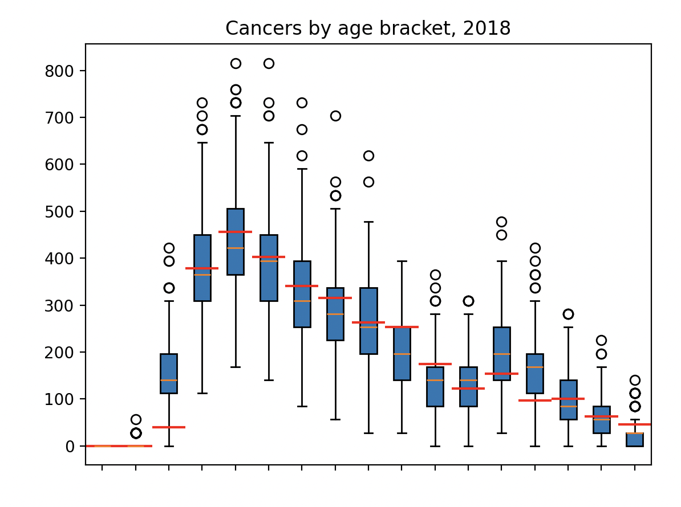
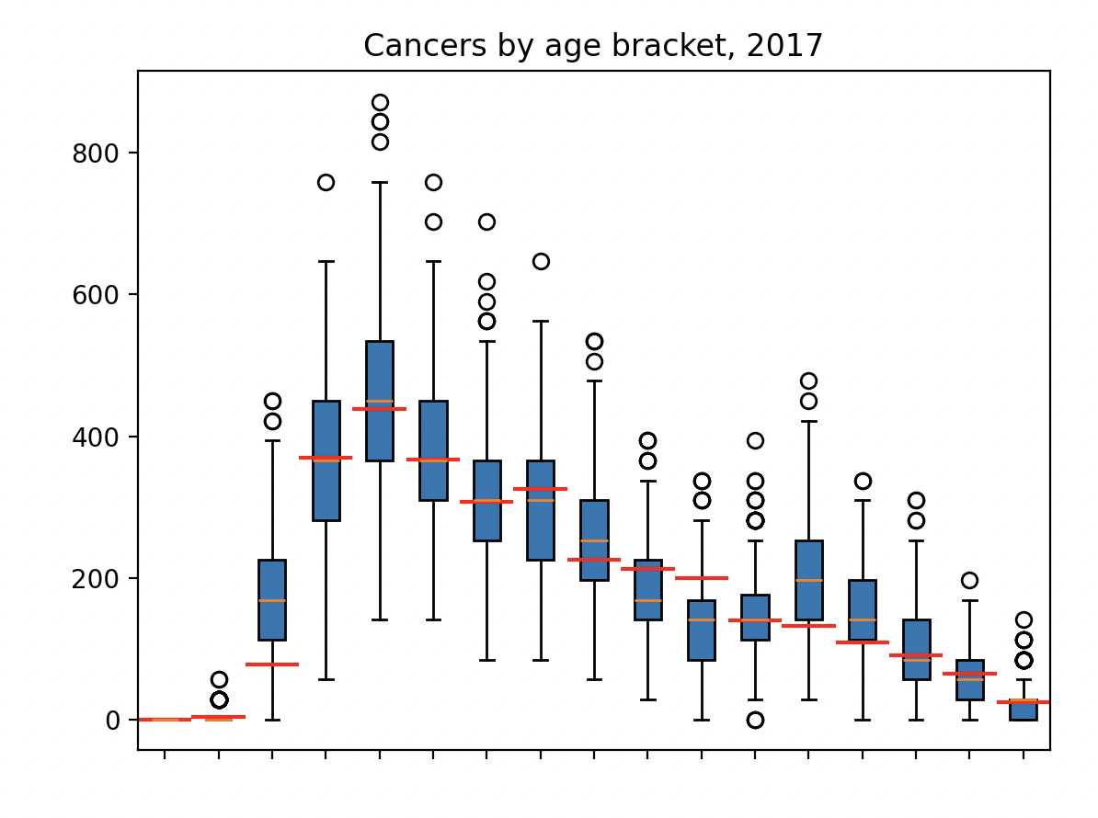
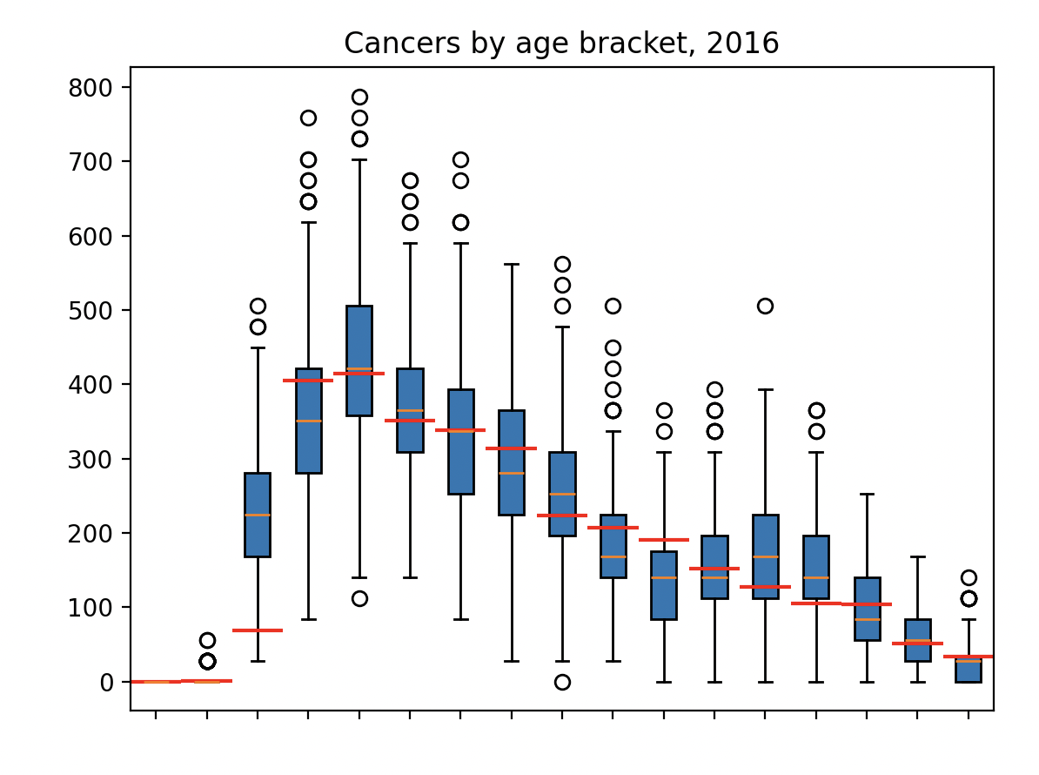
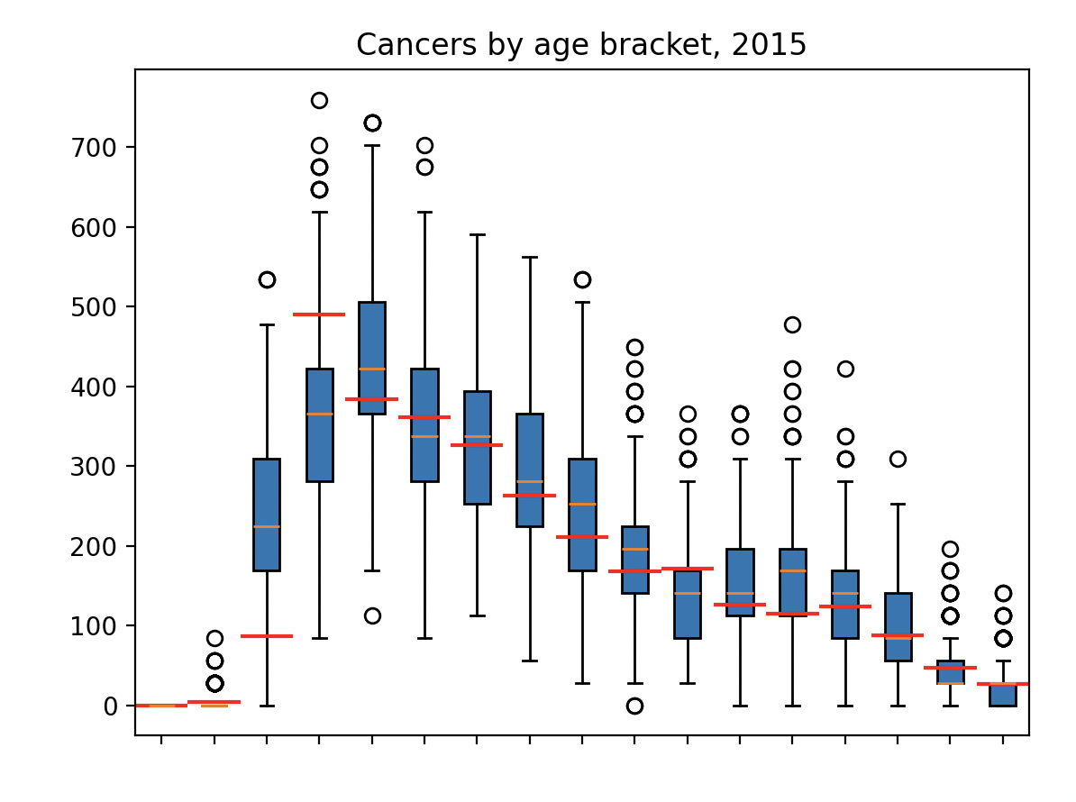
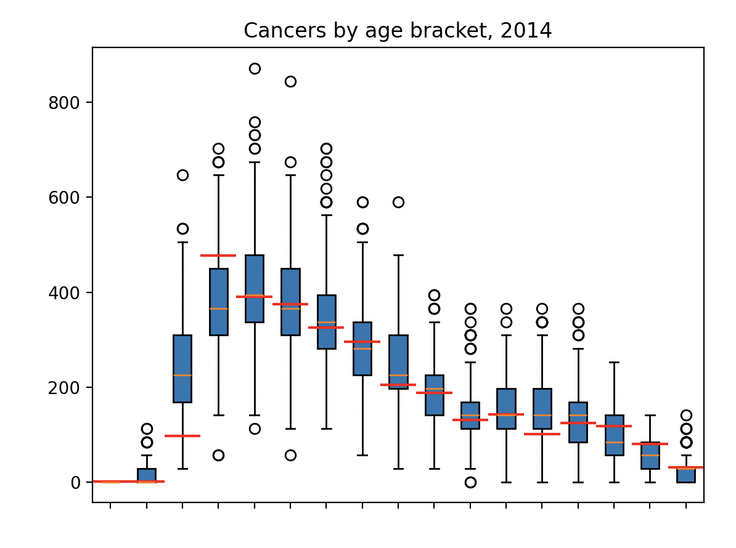
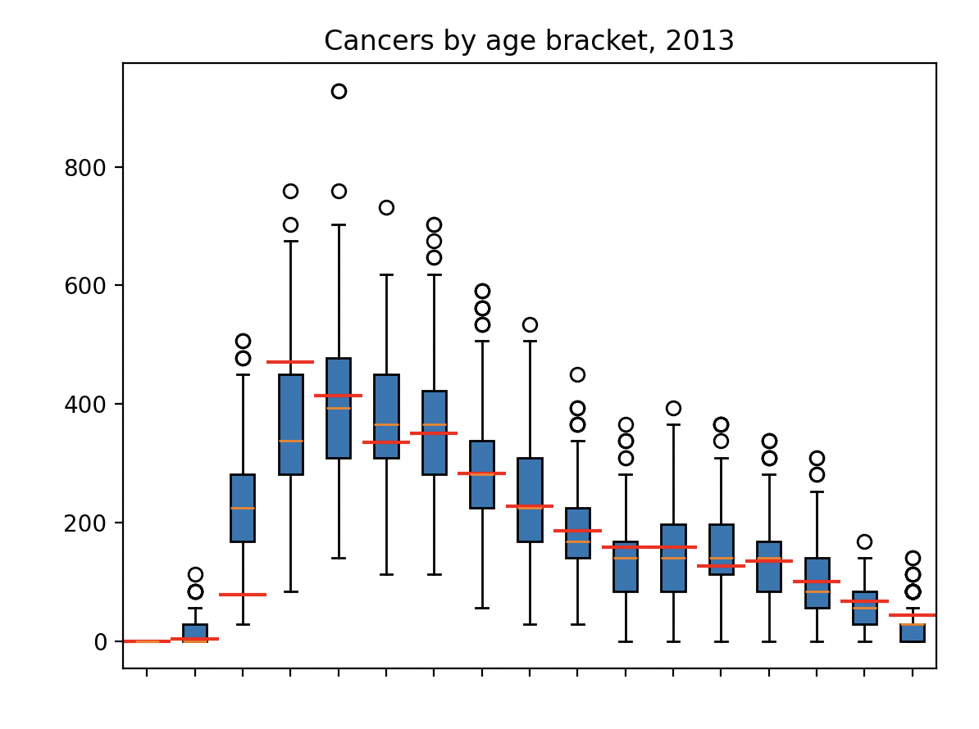
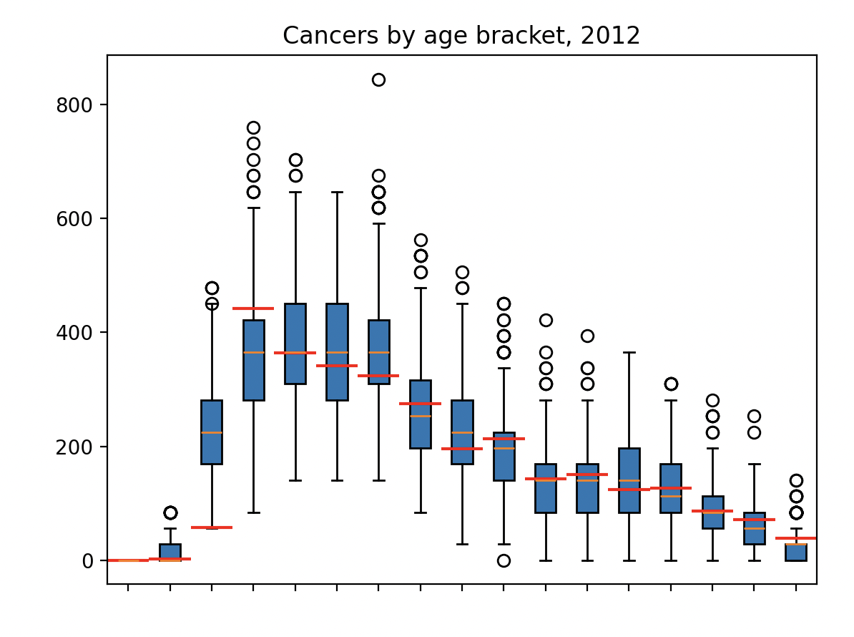
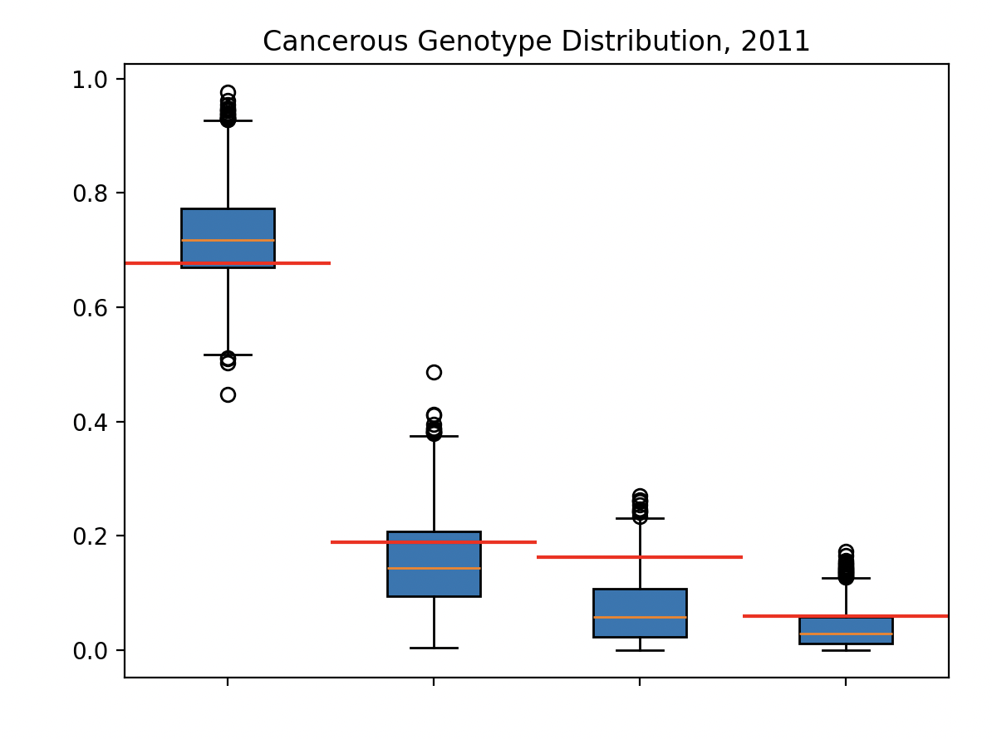
Info on total GOF:
min:0.15595493188890786
LQ:0.20988758325051046
median:0.23605016132409584
UQ:0.26391148158556316
max:0.3950271436098979
(recall, this is for final pooled calibration project_modelling/calibration_results/FinalPooledCalibration_8_68_76_55_55_9_9__96_7_13.pickle)

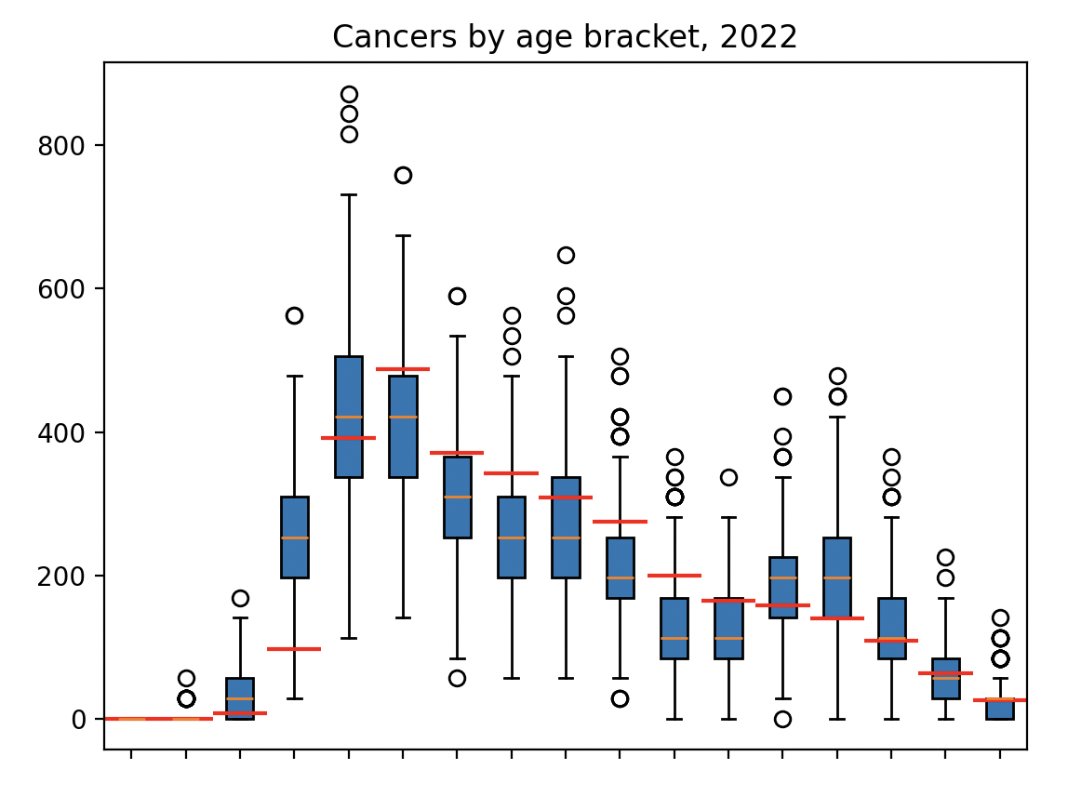
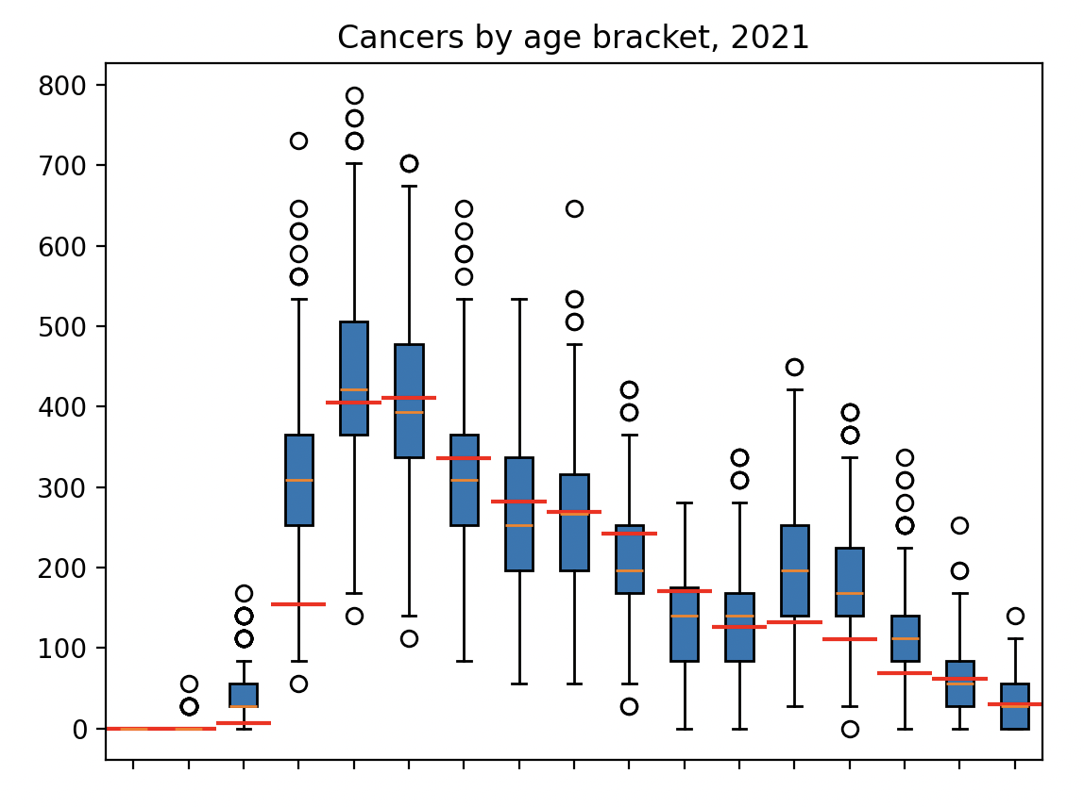
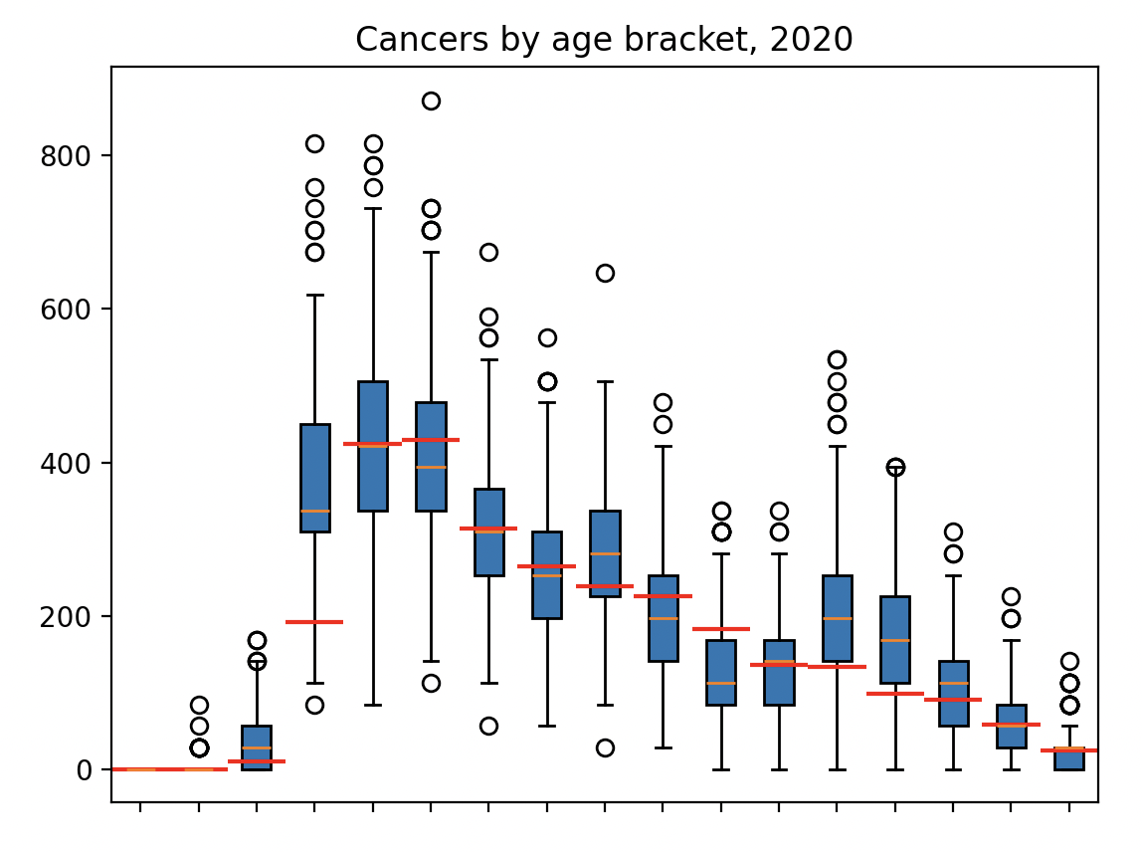
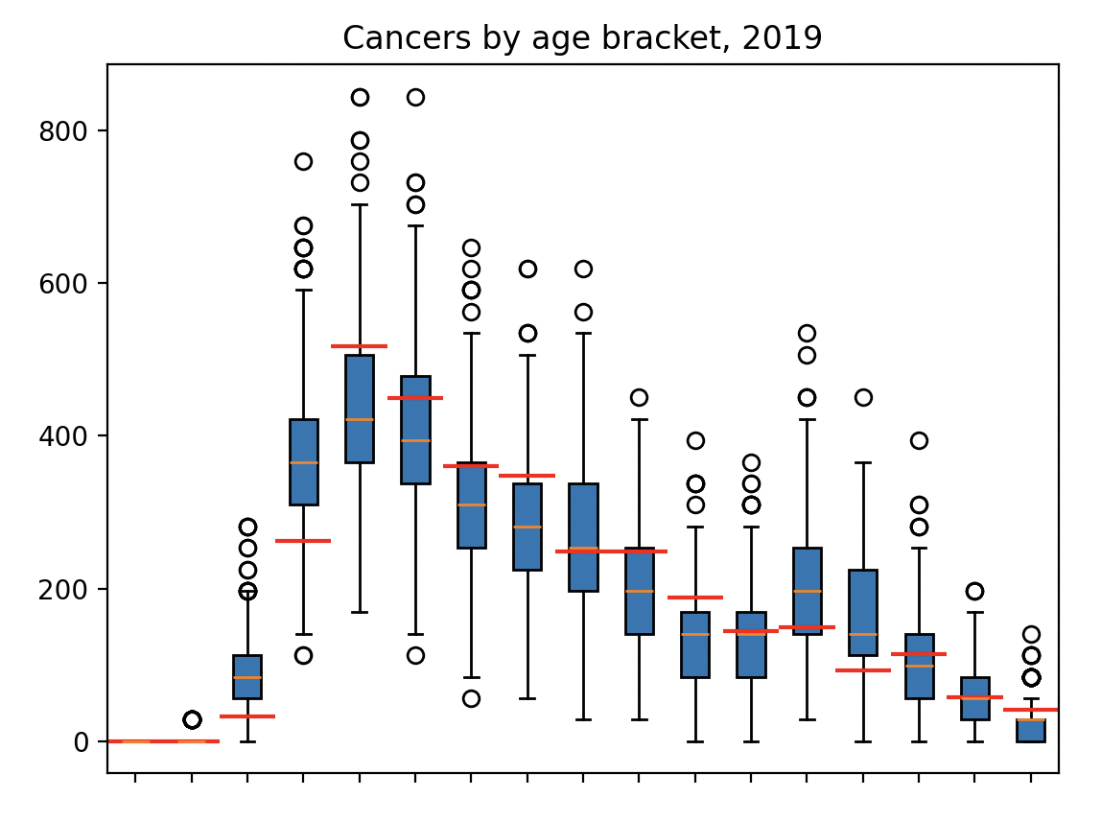
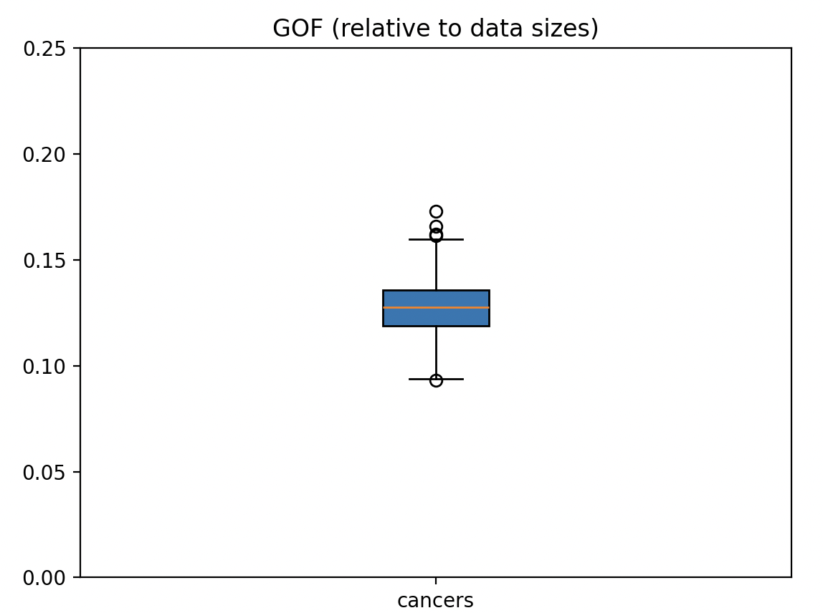
Info on total GOF:
min:0.09316095578918471
LQ:0.11876253231687392
median:0.1274896905062973
UQ:0.13581976477695773
max:0.17281597592893094

